
USER MANUAL
Version 1.0

Bruno Merven and Andrew Marquard

Energy Research Centre
University of Cape Town

Contents
1 Objective of tool 3
2 Overview of methodology 3
3 System Parameters 3
3.1 Demand parameters 3
3.2 Technology parameters 4
3.3 Fuel parameters 5
4 Design Variables 5
4.1 System design/investment planning process 5
4.2 Complete list of indicators 5
5 Results produced 8
5.1 Total power-system costs 8
5.2 Emissions 8
5.3 Comparison of scenarios 8
6 More advanced parameters 8
6.1 The projection of electrical energy demand, and power demand 8
6.2 Selection of technology and fuel cost parameters/specifying new references 10
7 Specialized sections 10
7.1 Calculation of system costs (incl. post 2030 costs) 10
7.2 Conversion of technology costs into local currency (2008) 11
7.3 Calculation of dispatch 11
7.4 Calculation of LOLP and the Wind PDF’s 12
Appendix 1 Setting up LOLP Excel add-in 13

Objective of tool
The objective of SNAPP is to facilitate the development of future electricity scenarios in a non-challenging but rigorous modeling framework. The aim of doing this is to encourage a wider range of civil society actors(and anyone else who is interested) to participate meaningfully in debates on our electricity future, both through producing their own scenarios, as well as through learning about the way that the electricity system responds to changes.

Overview of methodology
SNAPP simulates the South African electricity system at the generation level. It currently excludes any aspects of the transmission or distribution system other than losses. Users specify the investment plan from 2010 to 2030, and SNAPP, using a number of indicators, calculates the reliability of the system, the dispatch from each technology, the costs of the system, the investment requirements, and the emissions. SNAPP also calculates the individual levelised cost for each technology. Two scenarios can be constructed, which allows comparison between different investment plans.

System Parameters

Demand parameters
Figure 1 ESI 2006 Stats Energy Balance Diagram
Figure 1 shows how the electrical energy balance is summarized in the Electricity Supply Statistics published by NERSA for 2006. In SNAPP, in the “Elec Demand” sheet, the formulation of the electrical energy balance is slightly modified, in such a way that large generators, imports and exports are at the same level, distributed generators and demand reduction techs (SWH) are downstream of distribution, as shown in Figure 2.
Figure 2 SNAPP formulation of electrical energy balance
The electrical energy demand growth downstream of distribution is the main driving parameter. This has been calibrated up to 2014 using Eskom’s adequacy report online facility. Post 2014 growth is based on LTMS reference case. This is different to what was used in the 15% renewable by 2020 study, where LTMS growth rates were applied throughout the study horizon.
The peak power demand is based on the load factor and the electrical energy demand. The load factor is assumed to remain constant at the 2006 value over the study horizon. This simplistic assumption assumes no dramatic change in the structure of the national demand for electricity over the study period. This assumption can be improved by using mode detailed demand side models (MARKAL/TIMES, MAED-D+MAED-EL, etc.).
The electrical energy demand and power demand, and penetration of demand reduction techs over the study period are the same for both system design cases (ref. and alt.). Should comparisons between existing and alternative demand scenarios be required, new files must be created.

Technology parameters
The system can accommodate up to 20 different technologies in the analysis. Out of the 20, there are 9 pre-specified technologies. For the others, the user can select from a list of technology types, which ones to include in the analysis, in the “Tech Parameters” sheet.
The parameters that characterize each technology type are:
- Capital cost and learning rate
- Fixed O&M costs
- Variable O&M costs
- Efficiency
- Availability
- Lifetime
- Unit Size
- Forced Outage Rate
Other than the learning rate (based on LTMS), those parameters are all referenced from the sheet “TechnologyDataRaw”. In the “TechnologydataRaw” sheet, the user can select which reference to use in the analysis for each technology type, in column A. Select ‘1’ to chose the reference and ‘0’ to discard a reference. Care must be taken that not more than one reference is chosen for one technology type, or that no reference is chosen for a technology type selected for the analysis.

Fuel parameters
The preset fuel prices are specified in Rands/GJ for all energy carriers. These are then converted to Rands per MWh of output, using the efficiency of the specified technologies. Initial fuel prices were derived from a number of sources: coal prices were based on prices in NIRP3, which were compared to current coal prices and adjusted; liquid fuels prices were based on the Basic Fuel Price plus the wholesale margin specified by the Department of Energy, and nuclear fuel prices were based on prices on a 2008 MIT study of the nuclear power industry. Prices for existing coal plants are lower than prices for new coal plants. Prices are escalated as follows: 1) coal prices – 10% of coal is assumed to be bought on the spot market, and escalates with the crude oil price; the remaining 90% is assumed to be bought on long-term contracts, and remains constant; 2) the Basic Fuel Price component of the liquid fuels prices is escalated in proportion to the crude oil price, which is assumed to increase from the 2009 price of USD70 per barrel to USD150 per barrel by 2030, and 3) the nuclear fuel price is escalated from the 2008 level by 0.5% per year (derived from the MIT study, which bases this rate on a projection for the uranium price).
Users can choose from these preset projections, or specify their own: either by entering a time series in the fuel sheet, or by specifying a growth rate per year. Users can choose which approach to use in the fuel costs sheet.

Design Variables

System design/investment planning process
Once the demand, technology and fuel parameters have been reviewed, the investment plan/system design can begin. This is done in the “Investment Plan” sheet for a reference case and an alternative case. The process to be followed is simple: The user is required to enter for each technology present in the technology list how many new units of each technology are to be added each year over the study horizon, using the indicators as feedback.

Complete list of indicators

Reserve Margin
The reserve margin is a measure of the generating capacity available over and above the amount required to meet the system demand (power in MW) requirements to allow for such factors as generator breakdown, severe weather, demand forecast uncertainty and transmission problems that could result in a loss of generation.
Reserve Margin = (installed capacity – maximum demand)/maximum demand.
The lower the reserve, the higher are the risks of blackouts. The higher the reserve, the lower are the risks of blackouts but the higher the investment expenditure. There is currently no explicitly defined generation security standard in South Africa for electricity generation. NIRP2 used a 10% reserve level in its base case, NIRP3 used 19%, and Eskom has recently stated that a reserve of 15% to 25% is the desirable range, however, this is higher than what has been considered in the past.

Reserve Margin (AF)
In SNAPP another reserve margin indicator is calculated that takes into account what percentage of the installed capacity of each technology type can contribute to the capacity meeting the peak(MW). This indicator is called Reserve Margin (AF)
$$RM\left(AF\right)=\left(\sum_{i=1}^{n}{c_{i}{AF}_{i}}/\max{demand,}\right)-1,$$
where c_{i} is the installed capacity of tech i, AF_{i} is the available capacity (on average) that is able to contribute to meeting peak demand. AF_{i} for wind was set in the NIRP3 to 23%, and in the WWF study to 10%.
There are 4 RM(AF) indictors in SNAPP:
- RM (AF) – domestic capacity only: where only domestic generators are included
- RM (AF) – including interruptible supply: where supply capacity to certain large industrial sites can be interrupted to help the grid (e.g. BHP MOZAL, Skorpion etc.) is included in the calculation of RM.
- RM (AF) – including imports: where imports are also included in the calculation of RM. In the earlier years this consists of the hydro plant Cahora Bassa in Mozambique, if additional dispatchable import capacity becomes available, e.g. Mempenda Incua, Inga, and this new capacity is specified in the “Elec Demand” sheet, then it would also be included in the calculation of this indicator.
- RM (AF) – including imports and interruptible: where both interruptible contracts and imports are included in the calculation.

LOLP
The reserve margin is a known and accepted deterministic indicator of the reliability of a system. However, it does not take into account some system characteristics which are also affect the reliability of a system, such as the size of the individual units that make up a system in relation to the size of the system and their individual outage rates; random weather fluctuations that may affect both demand and supply (in the case of wind). Reliability assessments are then done by using probabilistic approaches/indicators such as LOLP (Loss of load probability). LOLP is a reliability index that indicates the probability that some portion of the load will not be satisfied by the available generating capacity. LOLP is normally expressed as a ratio of times: for example, 0.1 days per year, equals a probability of 0.0274% (i.e. 0.1/365). Target LOLP levels are typically set in the USA, and Europe for long-range planning. In SNAPP, it is calculated by an excel add-in called lolp.xll, that needs to be installed (see appendix 1 on how to install the add-in). The calculation can either be executed live, or calculated only when the “calculate” button is pressed (a time-stamp is updated every-time, to help the user keep track of when the last update was made). When using a high number of simulations, which is recommended to get more consistent estimates, then the “live” calculation can slow down the update of the spreadsheet every-time a cell is updated.

Energy Reserve
The South African system is currently capacity constrained rather than energy constrained, so in the near term it is sufficient to compare installed capacity vs peak demand for reliability using RM and LOLP. Should the system evolve to one made up of a large portion of technologies with relatively low availability (e.g. wind, solar, hydro) then it is possible that the system will switch from being capacity constrained to energy constrained (as the case in Brasil). Testing capacity vs peak demand is no longer enough for evaluating security of supply. The energy reserve margin must then also be considered. It is proposed to keep the energy reserve margin above 10% (this value still needs further research).
$$Energy Reserve=(\sum_{i=1}^{n}{c_{i}a_{i}×8.76})/(ED+{PS}_{in}+Exp-Imp)-1,$$
where c_{i} is the installed capacity of unit i (in MW incl. pump storage), a_{i} is the availability (max capacity factor) of unit i, ED is the energy demand (GWh), PS_{in} the energy input to pump-storage units, Exp and Imp are the electrical energy exports and imports.

Percentage generation by fuel
There are 5 such indicators currently configured, which simply state how much of the total electricity generated domestically comes from each of the different fuel groups: coal, nuclear, oil, gas and renewables.

Water
Total water consumption is currently not calculated, but will be in the next version.

Employment
Workforce employed in the energy sector is currently not calculated, but will be in the next version.

System Costs and average electricity costs
System costs include the capital costs (annualized at the defined discount rate), fixed and variable operation and maintenance, and fuel costs.

Emissions
Emissions are calculated using emissions factors for each fuel on total fuel use. Factors are derived from emissions factors used in the Long Term Mitigation Scenarios, which in turn were derived from either IPCC factors (for liquid fuels), factors derived from South African studies (for coal), or factors from IEA sources (for non GHGs).

Emissions Intensity
Emissions intensity is defined as GHGs per electricity output, and is a useful indicator for comparing electricity systems with different outputs.

Results produced

Total power-system costs
Several types of power system costs are reported in SNAPP. The first is total system costs (annualized capital costs, fixed and variable operation and maintenance and fuel costs for the whole system – technical details below in section 7. The second is the average annual electricity supply cost, which is simply the total system cost divided by the total energy produced. This not NOT synonymous with the average electricity price (which is in any case set by the regulator), but is indicative of what price movements might result from specific technology choices. In addition, users should bear in mind that the total electricity price comprises elements from generation, transmission and distribution, and that the generation cost only comprises one price element.
Users can add a carbon tax in the system costs sheet, for each scenario, which is reported as part of the total system costs.

Emissions
Emissions are calculated from the fuel consumption of each technology for GHGs and other emissions (N2O, SO2,NMVOCs, CO), and are also reported for each technology in each scenario.

Comparison of scenarios
Each major sheet (investment plan, system costs, emissions etc) has three components – a reference case, an alternative scenario, and a comparison between scenarios. The comparison area compares results in each area, and in the investment plan sheet, one can compare different indicators.

More advanced parameters

The projection of electrical energy demand, and power demand
The energy demand downstream of distribution is projected using a 2006 figure and growth values over the study period. The projection at this level allows for analysis of demand reduction measures (to a limited extent), analysis of the penetration of distributed generation options, as well as efficiency improvements in the distribution and transmission network. The peak demand is normally considered upstream of transmission, at the generation level, and this is calculated by applying a load factor to the energy demand. As mentioned before, detailed analysis of the load curve is beyond the scope of this tool and should be done using other more appropriate tools (e.g. MAED-EL).

Alternative demand growth scenarios
Two alternative demand growth time series are proposed. The user can select which one is to be used by clicking on cell C9 in the “Elec Demand” sheet. The first one is roughly calibrated on the Eskom Adequacy online facility projections of the peak demand on the Eskom system up to 2014. The growth applied to the rest of the study period is taken from the LTMS reference case. The alternative growth scenario is based on an industry efficiency scenario of the LTMS model. Other alternatives could be designed with care and the help of demand analysis models such as LEAP, MAED-D, MARKAL, etc.

Imports and Exports
The imported and exported electrical energy are based on the 2006 ESI stats figure and are assumed to remain constant over the study horizon. It is possible for an experienced user to experiment with different import and exports scenarios. There is a national policy on the maximum electricity South Africa is prepared to import, set at 15% of total electricity upstream of local transmission network. Demand reduction options
There is the possibility for the user to roughly analyze the impact of a roll-out of solar water heaters in high income households. This is done in the “Elec Demand” sheet in rows 48-57.
The user must first specify for each year the number of units installed, either replacing electric geysers or being installed instead of electric geysers, taking care that the maximum penetration potential is not exceeded.
The investment cost for a standard solar water heating unit, over and above the cost of a standard electrical geyser is proposed but can be adjusted by the user if better data is available. The cost of the SWH program is incorporated in the total system costs.
A figure for the power and energy reduction per unit installed is proposed, and could be reviewed if well referenced data is available.
A more advanced user can add other demand reduction options (e.g. SWH in the commercial sector), by copying rows 49-57, inserting them in row 59, and including the demand reduction (in power and energy), and the costs in the totals (currently in rows 73-75). Again, these other demand reduction options must be programmed with care, and if possible with the help of demand analysis tools such as MAED and LEAP.

Distributed Generation
There is also the possibility of analyzing the impact of a roll-out of solar PV at a household level. This is done in rows 59-69 of the “Elec Demand” sheet.
The user must first specify the number of units to be installed each year, taking care again that the maximum potential is not exceeded.
The investment cost per kW can be specified, and gets accounted for in the total systems cost.
PV systems without inverters and batteries are proposed as the default. This implies no power reduction during peak demand that normally occurs after sunset, there is only an energy demand reduction. Should power reduction be envisaged, then the cost must be adjusted accordingly. Like in the case of demand reduction opportunities, other distributed technology options can be added, by more advanced users.

Selection of technology and fuel cost parameters/specifying new references
Some space was left for the user to add new references. If the space is used up then the user has to either overwrite an existing reference or insert a new line with the new reference. The procedure for doing so is as follows (using the insertion of a new biomass reference as example):
- Add new reference name to reference list (below row 127)
- Insert a row where the new reference must go (right click row 13 -> insert row).
- Select “Biomass” in blank cell B12
- Select new reference name in C12.
- Select currency, year, overnight cost,
- Enter capital, Fixed O&M, Variable O&M in G12:I12
- Insert a row in the table below (right click row 53 -> insert row)
- Copy Cells A52:Y52 and paste in A53:Y53
- Copy cells J11:P11 and paste in J12:P12
- Enter other tech parameters in Q12:W12
- Select new reference by putting ‘1’ in A12 and ‘0’ in previously selected reference.
For fuel prices, the user can choose one of three options at the top of the fuel sheet:
- An ERC projection of fuel prices, described above
- A user-defined series, defined by % growth in real prices per year
- A user-defined time series – users can copy time series for the complete period into the indicated space.

Specialized sections

Calculation of system costs (incl. post 2030 costs)
System costs are calculated by adding four different components:
- The sum of the annualized investment costs of each power plant; in other words, the required annual repayment of the present value (which includes interest during construction) of each plant over the lifetime of the plant, at the defined discount rate.
- The fixed cost of each power plant in service
- The variable costs of each power plant (calculated from how much electricity each plant dispatches)
- The fuel costs for each plant
There are four variations of the Net Present Value (all discounted to 2009), reported in the investment plan sheet, which are calculated:
- 2010 to 2030
- 2010 to 2030, including any costs from a carbon tax
- 2010 to 2050
- 2010 to 2050, including any costs from a carbon tax
Costs after the modeling period (2031 to 2050) are calculated by assuming that the composition and output of the system remains identical to 2030, with two exceptions: fuel prices are projected to 2050, and if capital costs have changed (due to learning), retired capacity is built at the prevailing capital cost (in other words, if there is 100 MW of wind power in 2030, and it retires in 2032, it is replaced by 100 MW of wind power at the capital cost in 2032, which will be lower than that in 2030). Since there is an annualized cost associated with each unit of capacity, except in the former case of declining capital costs, the annualized cost remains the same. Dispatch from each plant remains constant.
Investment costs are calculated by distributing the overnight investment cost over the leadtime of each unit of new capacity according to ratios sourced from NIRP3; to this is added interest during construction at the defined discount rate. Thus, investment costs and total system costs are different indicators, which account for capital expenditure differently. The purpose of calculating investment costs is to explore the borrowing implications of financing a large build programme; investment costs obviously do not account for the total costs of specific options.

Conversion of technology costs into local currency (2008)
The conversion of technology costs into local currency is subject to some uncertainty. There are several different methods for doing this which can lead to different outcomes. Typically, costs are expressed in a foreign currency in a particular year (for instance in USD in 2005). In order to express these costs in real terms, it is necessary to convert the cost into Rands, and then correct for inflation or vice versa. Since differences in inflation between countries do not entirely account for currency fluctuations, one gets (sometimes significantly) different outcomes by reversing these two steps. The approach we have adopted aims to mimic the cost faced by a South African developer of a specific power project. We assume that there will be a percentage of local content in each project, the cost of which will escalate in nominal terms according to the South African producer price index. The rest of the cost will be imported, and will this escalate by the producer price index in the relevant country. We assume for each cost that this will occur in a ratio of US dollars and Euros. Thus, the method for converting costs to a real cost in Rands in a specific year is as follows:
- Divide the cost into three components: a Rand component, a USD component and a Euro component
- Translate, via the applicable producer price index, the price into the desired year (into real terms)
- Convert into Rands at the applicable exchange rate

Calculation of dispatch
Dispatch in SNAPP is relatively simple. It represents annual dispatch between different technologies fairly accurately, but does not necessarily simulate dispatch during peak periods accurately. The dispatch methodology begins with a minimum and a maximum quantity of output for each plant which should be dispatched. This quantity is fairly low for coal plants (around 25%), but set at a maximum for plants such as nuclear plants, which would be dispatched anyway first, and others such as OCGT plants (set at 3%), where the minimum share is the estimate of the use of the plant during peak times, or renewable plants such as wind plants, which would be dispatched in most circumstances. After the specified minimum has been dispatched, additional demand is met from lowest to highest short-run marginal cost from the remaining available capacity (mostly coal, followed by other plants such as OCGT plants if there is a shortage of capacity).

Calculation of LOLP and the Wind PDF’s
The LOLP indicator is calculated for every year over the study horizon. It is calculated only the peak hour in each year, and is more suited to capacity constrained systems, such as the one we have in SA at the moment, providing a better indication of reliability than just the reserve margin. It is however, less useful for energy constrained systems, such as ones with large hydro components.
The LOLP in a particular year is a function of the total number of thermal units (conc. solar units are considered thermal) installed in that year (N), the size of each thermal unit (c_{i}), the forced outage rate (FOR_{i}) of each thermal unit, the installed wind capacity (2 categories: w₁ and w₂), the pdfs of output of wind for each wind category, and the peak demand in that year (D). It is calculated by Monte Carlo simulation as follows:
- For each simulation:
  - Draw a set of uniformly distributed random numbers from 0 to 1 for each thermal unit in the system, X_{i}.
  - Calculate available total capacity of thermal units to meet the peak:
$$C_{T}=\sum_{i=1}^{N}{\left(X_{i}>{FOR}_{i}\right).c_{i}}$$
  - Calculate available capacity from wind by sampling from the wind pdfs then multiplying by w_{1,2} to give W_{1,2}
  - If total capacity = W₁+W₂+C_{T} < D then increment the Failures counter
- LOLP = Failures/number of simulations.

Appendix 1 Setting up LOLP Excel add-in
Step 1: Go to Excel Options
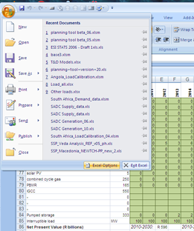
Step 2: Go to Add-Ins -> Manage Excel Add-ins -> Go…
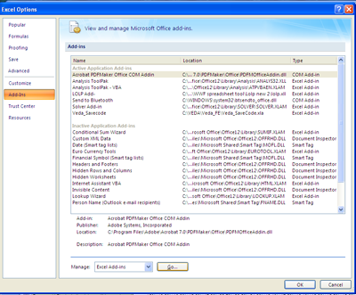

Step 3: Click Browse -> locate lolp.xll and click “Ok”
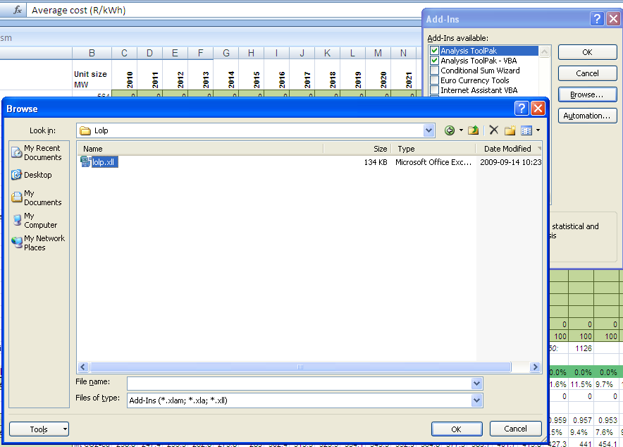

If LOLP function doesn’t work (ie give numerical result when LOLP buttons are pressed) then:
Go to:
http://www.microsoft.com/downloads/details.aspx?familyid=A5C84275-3B97-4AB7-A40D-3802B2AF5FC2&displaylang=en

and download and run the MS VC++2008 Redistributable Package from that page and then repeat step 1-3 again, or run: vcredist_x86.exe if you have it.

Deutch et al. Update of the MIT 2003 Future of Nuclear Power – An Interdisciplinary MIT Study. MIT 2009

