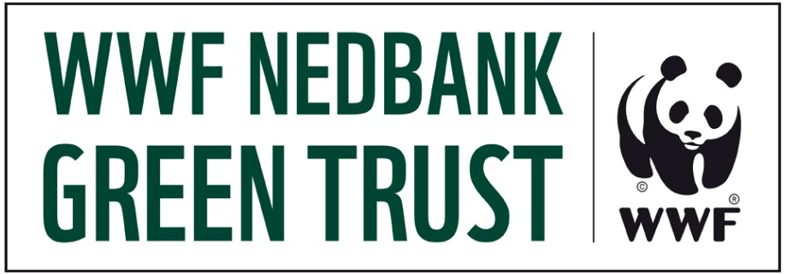

Project Concept Proposal
Submission
- Do not complete unless you have studied the “WWF Nedbank Green Trust Application Guidelines March 2012”
- Do not exceed two pages (excl. the classification table)
- In the Classification Table, if “Other”, please insert a category not covered, but relevant to the overall classification of the project.
- Please only attach relevant supporting documentation that supports the information entered below.
Organization (legal entity) | Type legal registered name here | Applicant name | Click here to enter text
Applicant Email | Click here to enter text. | Applicant contact no. | Click here to enter text.
Project Title | Click here to enter text. | Date of submission | Click here to enter a date.
WWF-SA Contact | Click here to enter text.
Concept Description
- Strategic Intent | Click here to enter text.
- Objectives | Click here to enter text.
- Planned Activities | Click here to enter text.
Strategic Approach Statement | Click here to enter text.
Target audience / stakeholders / beneficiaries | Click here to enter text.
Return on Investment for the Green Trust | Click here to enter text.
Total Amount | Click here to enter text.
Funding Source | WWF Nedbank Green Trust
Other Funding Sources | Click here to enter text.
Period till return on investment | Click here to enter text.
Budget
Budgeting per financial year | Projects Costs | Budget Notes/Description
Year 1 | Click here to enter text. | Click here to enter text.
Year 2 | Click here to enter text. | Click here to enter text.
Year 3 | Click here to enter text. | Click here to enter text.
Totals | Click here to enter text. | Click here to enter text.
Decision | INTERNAL USE
Delegation of Authority | INTERNAL USE

Submission Classification (Tick as many boxes as relevant to your application)
WWF-SA Strategic Goal | Maintain & Enhance the integrity of South Africa’s Ecological Assets | ☐ | Province | Eastern Cape | ☐
 |  |  |  | Free State | ☐
 |  |  |  | Gauteng | ☐
WWF-SA Strategic Goal | Ecological systems and their services underpin social and economic well being | ☐ | Province | Kwa-Zulu Natal | ☐
 |  |  |  | Limpopo | ☐
 |  |  |  | Mpmulanga | ☐
 |  |  |  | Northern Cape | ☐
WWF-SA Strategic Goal | Address risks & opportunities posed by climate change | ☐ | Province | Northern Province | ☐
 |  |  |  | North-West Province | ☐
 |  |  |  | Western Cape | ☐
 |  |  |  | National | ☐
Global Programme Framework Priorities
GPF Priority 1 | Places | ☐ | GPF Priority 4 | Cape Rivers & Streams | ☐
GPF Priority 1 | Species | ☐ | GPF Priority 4 | Patagonian South west Atlantic | ☐
GPF Priority 1 | Footprint | ☐ | GPF Priority 4 | African elephant | ☐
GPF Priority 1 | Global Drivers | ☐ | GPF Priority 4 | African rhino | ☐
GPF Priority 2 | Freshwater | ☐ | GPF Priority 4 | Marine cetaceans | ☐
GPF Priority 2 | Terrestrial | ☐ | GPF Priority 4 | Marine turtles | ☐
GPF Priority 2 | Marine | ☐ | GPF Priority 4 | Corals | ☐
GPF Priority 2 | Flagship species | ☐ | GPF Priority 4 | Pelagic sharks | ☐
GPF Priority 2 | Footprint-impacted species | ☐ | GPF Priority 4 | Reef sharks | ☐
GPF Priority 2 | Energy/Carbon | ☐ | GPF Priority 4 | Southern Ocean Albatrosses | ☐
GPF Priority 2 | Commodities | ☐ | GPF Priority 5 | Black rhino | ☐
GPF Priority 2 | Water | ☐ | GPF Priority 5 | White rhino | ☐
GPF Priority 2 | Public Sector finance | ☐ | GPF Priority 5 | Baleen whales | ☐
GPF Priority 2 | Private Sector Finance | ☐ | GPF Priority 5 | Toothed whales | ☐
GPF Priority 2 | Private Sector Standards | ☐ | GPF Priority 5 | Dolphins | ☐
GPF Priority 2 | National and International Natural Resource Management Policy | ☐ | GPF Priority 5 | Green turtle | ☐
GPF Priority 2 | Consumption Choices | ☐ | GPF Priority 5 | Hawksbill turtle | ☐
GPF Priority 3 | Fynbos | ☐ | GPF Priority 5 | Leatherback turtle | ☐
GPF Priority 3 | Namib-Karoo-Kaokoveld | ☐ | GPF Priority 5 | Loggerhead turtle | ☐
GPF Priority 3 | Southern Ocean | ☐ | GPF Priority 5 | Olive Ridley turtle | ☐
GPF Priority 3 | Mammal | ☐ | GPF Priority 5 | Whale Shark | ☐
GPF Priority 3 | Reptiles | ☐ | GPF  Non Priority | National Priority | ☐
GPF Priority 3 | Invertebrates | ☐ | GPF  Non Priority | Cross Cutting | ☐
GPF Priority 3 | Fish | ☐ | GPF  Non Priority | TRAFFIC | ☐
GPF Priority 3 | Bird | ☐ | Other | Click here to enter text. | ☐
GPF Priority 3 | Crops | ☐ | Other | Click here to enter text. | ☐
GPF Priority 3 | Meat | ☐ | Other | Click here to enter text. | ☐
GPF Priority 3 | Fish Market Transformation (MT) | ☐ | Other | Click here to enter text. | ☐
GPF Priority 3 | Fish Smart Fishing Network Initiatives (SF) | ☐ | Green Trust Specific | Environmental Leaders | ☐
GPF Priority 3 | Wood | ☐ | Green Trust Specific | Schools Education | ☐
GPF Priority 3 | Water | ☐ | Green Trust Specific | Grass roots Community | ☐

